**STATIC LINKING**

SINGLY LINKED LIST

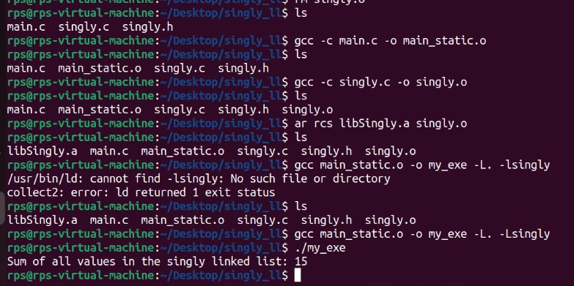

DOUBLY LINKED LIST

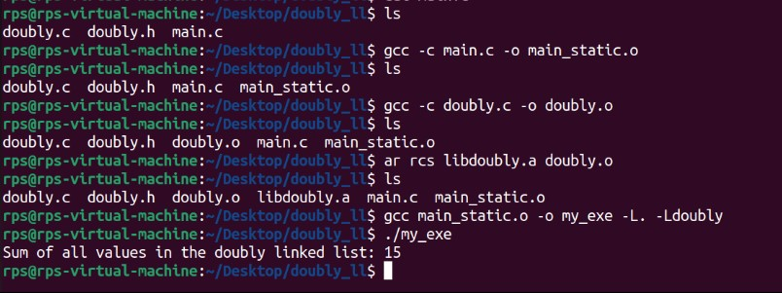

**COMMANDS FOR RUNNING FILES THROUGH STATIC LINKING**

* **gcc –c main.c -o main_static.o** : This will generate **output file** for **the main.c file** with name **main_static.o**.
* **gcc -c doubly.c –o doubly.o**  : This will generate **output file** for **the doubly.c file** with name **doubly.o**.
* **ar rcs libdoubly.a doubly.o**:This will create a static library archive named with name **libdoubly.a** from the object file **doubly.o.** This command combines one or more object files into a single archive file.
* **gcc main_static.o –o my_exe –L. –Ldoubly :** The gcc command is used to link the object file main_static.o with the static library **libdoubly.a** and create an executable named **my_exe**.
* **./exe :** It is for running program through executable file.

**DYNAMIC LINKING**

SINGLY LINKED LIST

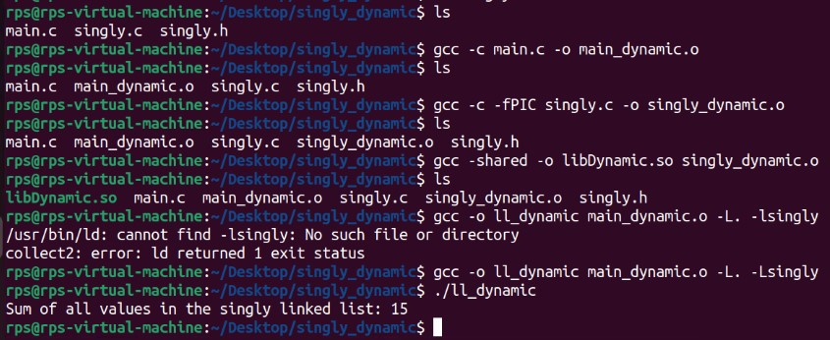

DOUBLY LINKED LIST

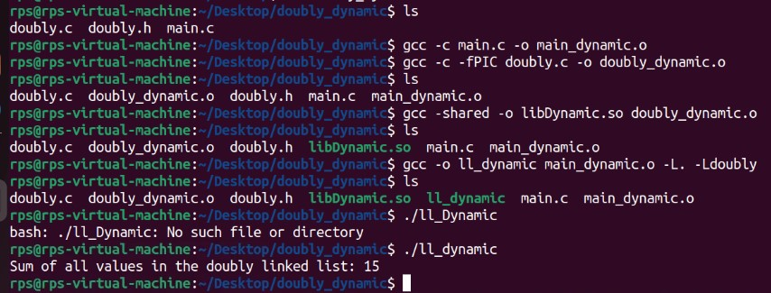

***COMMANDS FOR RUNNING FILES THROUGH DYNAMIC LINKING***

* **gcc -c main.c –o main_dynamic.o :** This will generate **output file** for **the main.c file** with name **main_dynamic.o**.
* **gcc -c fPIC doubly.c –o doubly_dynamic.o :** This is used to compile source file **doubly.c** into a position-independent object file i.e **doubly_dynamic.o.**
* **gcc -shared -o libdynamic.so doubly_dynamic.o :** This command is used to create shared library named **libdynamic.so** from the PIC object file doubly_dynamic.o.
* **gcc -o ll_dynamic main_dynamic.o –L. Ldoubly :** This is used to link the object file **main_dynamic.o** with the shared library **libdynamic.so** and create executable named **ll_dynamic**.
* **./ll_dynamic :** It is used to run my program through the executable file.